#### SCTR's Pune Institute of Computer Technology Dhankawadi, Pune

### AN INTERNSHIP REPORT ON

## Web Development Virtual Internship

### SUBMITTED BY

### Name: Abhishek Ulagadde

## Class: TE-01

## Roll no:31178.

**Under the guidance of**

## Prof. Preeti Jain



### DEPARTMENT OF COMPUTER ENGINEERING

ACADEMIC YEAR 2023-24



### DEPARTMENT OF COMPUTER ENGINEERING

**SCTR’s Pune Institute of Computer Technology Dhankawadi, Pune**

**Maharashtra 411043**

**CERTIFICATE**

This is to certify that the SPPU Curriculum-based internship report entitled

**“Web Development Virtual Internship”**

Submitted by

*Abhishek Ulagadde*

*(Roll No. 31178)*

has satisfactorily completed the curriculum-based internship under the guidance of *Prof. Preeti jain* towards the partial fulfillment of third-year Computer Engineering Semester VI, Academic Year 2023-24 of Savitribai Phule Pune University.

*Prof. Preeti Jain* Dr. G. V. Kale

Internship Guide Head

PICT, Pune Department of Computer Engineering PICT, Pune

Place:

Date:

**Acknowledgment**

It gives me great pleasure to present the internship report on “Web Development Virtual Internship”.

First, I would like to take this opportunity to thank my internship guide **Prof. Preeti Jain** for giving me all the help and guidance needed. I am grateful for his kind support and valuable suggestions that proved to be beneficial in the overall completion of this internship.

I am thankful to our Head of the Computer Engineering Department**, Dr. G.V. Kale**, for her indispensable support and suggestions throughout the internship work.

I would also genuinely like to express my gratitude to the Department Internship Coordinator**, Prof. P.P. Joshi**, for her constant guidance and support and for the timely resolution of the doubts related to the internship process.

Finally, I would like to thank my mentor, **Mrs. Arya Gupta** for his constant help and support during the overall internship process.

**Contents**

1. Title 3
2. Introduction 3
3. Problem Statement 4
4. Objectives and Scope 4
5. Methodological Details 5
6. Modern engineering tools used 6
7. Outcome/ results of internship work 7
8. Achievements 11
9. Reference 12
10. Future Work 13

**List of Figures**

1. **Weather frontend page** 8

#### Weather of Pune 8

#### Architectural Diagram 9

#### Home Page 9

#### About Page 9

#### Contact Page 10

#### Skills Page 10

# Title

Web Development Virtual Internship position in Prodigy for 4 weeks from 05 January 2024 to 05 February 2024.

# Introduction

It is a report on a Web Development Virtual Internship at Prodigy Infotech. **Prodigy Infotech** is an IT service and **IT consultancy company** that specializes in creating innovative solutions for businesses. It was a 4-week internship starting from 15 January 2024 to 15 February 2024. Through this internship, I got to learn various tools and techniques used in the web development field in the real world. By performing the various tasks, I got a wonderful opportunity to learn and develop new skills and gain hands-on knowledge.

The internship at Prodigy Infotech company was an invaluable opportunity to dive deep into the field of Web Development. The primary focus was on developing and refining design skills that are useful to enhance my portfolio. Under the mentorship of experienced professionals at Prodigy Infotech, the aim was to perform at least 2 tasks out of 5 so that I could get hands-on experience in this field.

This hands-on experience allowed me to apply theoretical knowledge to practical scenarios, enhancing my skills in HTML, CSS, and JavaScript and its frameworks like React.js and JQuery. Working closely with the Prodigy Infotech team, I learned about Application Programming design, User-Experience, and User-Design. This project not only honed my technical skills but also deepened my understanding of the strategic applications of Web Development across different sectors.

# Problem Statement

There was a total of 5 tasks which are assigned during the internship:

* 1. Create an interactive navigation menu that changes color or style when scrolling or when hovering over a menu item. The navigation menu should have a fixed position and be visible on all pages. Use HTML to structure the menu, CSS to style it, and JavaScript to add interactivity, such as changing the background color or font color of the menu when it is scrolled or when a menu item is hovered over.
  2. To build a stopwatch web application, you can use HTML, CSS, and JavaScript. HTML is used to structure the elements of the application. By implementing functions for starting, pausing, and resetting the stopwatch, as well as tracking and displaying lap times, users can accurately measure and record time intervals. With these technologies and functionalities, you can create an interactive and user-friendly stopwatch web application.
  3. To build a tic-tac-toe web application, you can use HTML, CSS, and JavaScript. By implementing functions to handle user clicks, track game state, and check for winning conditions, you can create an interactive and engaging tic-tac-toe game.
  4. Build a personal portfolio website that showcases your skills, projects, and accomplishments as a web developer. Design an attractive and visually appealing layout that captures visitors' attention. Include a home page with a captivating headline, professional photo, and skills summary. Provide an "About Me" section with a detailed background, education, and professional experience.
  5. Build a web page that fetches weather data from a weather API based on the user's location or a user-input location. Display the current weather conditions, temperature, and other relevant information.

# Objectives and Scope

1. Showcase Professional Skills and Projects.
2. Responsive and User-Friendly design.
3. Designing good UI-UX.
4. To get experience related to web development.
5. To gain knowledge and improve skills.
6. To know the workings of API.
7. Integrate multiple web pages like Map.

# Methodological Details

I used some tools and technology for both tasks, but the basic steps followed in each task are listed below:

**Planning and Analysis:** Requirements gathering to understand the project scope and user needs.

**Design:** User experience (UX) design to ensure the site is user-friendly and meets the intended audience's needs.

**Development:** Coding the website using HTML for structure, CSS for styling, and JavaScript for interactive elements.

**Version Control:** Using tools like Git to manage code versions and collaborate among development team members.

**Testing:** Identifying and fixing bugs and verifying user experience and site performance.

**Deployment:** Deployment of the Website to a server and setting up the Domain (if needed).

1. **Modern engineering tools:**

**Hyper-Text Markup Language:**

HTML (HyperText Markup Language) is the fundamental language used to structure content on the web. It utilizes a system of tags and attributes to organize and format web pages, ranging from simple text to complex multimedia integrations. HTML documents are structured with elements like <head>, <title>, <body>, and <p>, essential for defining parts of a web page. As the backbone of web development, HTML forms the building block for more advanced technologies like CSS and JavaScript, enhancing functionality and design.

**Cascading Style Sheet:**

CSS (Cascading Style Sheets) is a stylesheet language used to describe the presentation of a document written in HTML or XML. CSS enables web developers to separate content from design, allowing for more flexible styling options across multiple web pages by controlling layout, colors, fonts, and more. It uses selectors and properties to apply styles to elements identified within the HTML, supporting responsive designs that adjust content to different screen sizes and devices. This separation of content and style enhances both accessibility and maintainability of web applications.

**JavaScript:**

JavaScript is a powerful, high-level programming language used to create dynamic and interactive effects within web browsers. Unlike HTML, which structures content, and CSS, which handles page layout and style, JavaScript enables web pages to respond to user actions, modifying content on the fly, validating forms, and handling multimedia. It supports event-driven, functional, and imperative programming styles and can interact with the document content that resides in the browser, known as the DOM (Document Object Model). This makes JavaScript essential for adding interactive behaviors to web pages, enhancing user experience and website functionality.

**Bootstrap:**

Bootstrap is a widely used front-end framework that combines HTML, CSS, and JavaScript to facilitate rapid and responsive web development. It provides a grid system, pre-designed components, and ready-to-use plugins, allowing developers to create attractive and effective websites quickly across different devices.

# Outcome/ results of internship work

**7.1 Task 1 (Weather Website): -**

Figure 7.1.1 - Frontend Page

Figure 7.1.2- Weather of Pune.

# Architectural Diagram

API Call

Cloud Database

End User

**7.2 Task 2 (Personal Portfolio Website): -**

Figure 7.2.1- Home Page.

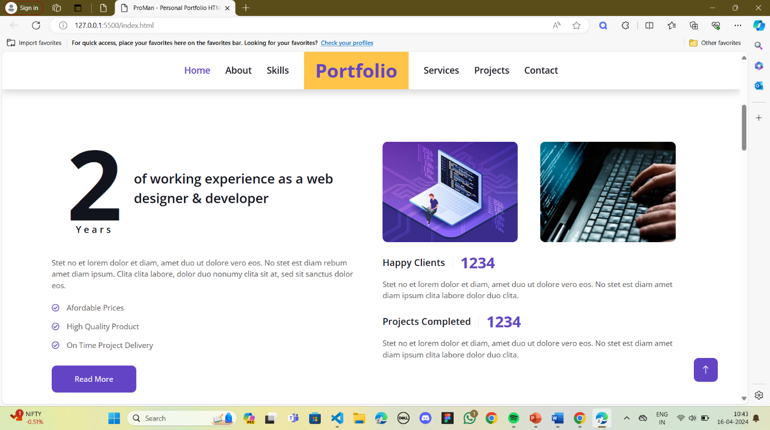

Figure 7.2.2- About Page.

Figure 7.2.3 - Contact Page.

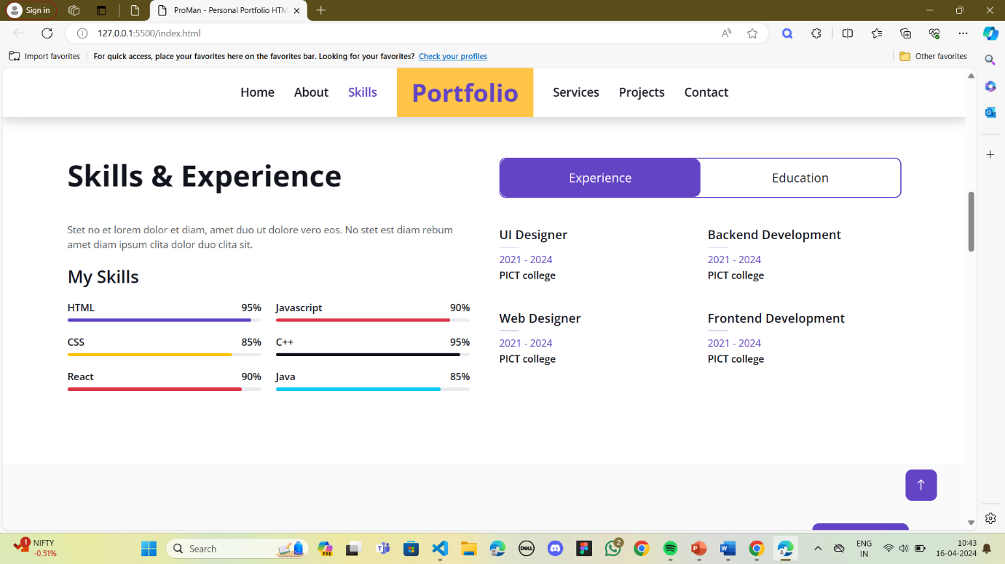

Figure 7.2.4- Skills and Experience Page.

# 

# Achievements

During my internship, I accomplished several key achievements:

1. Developed a weather app using HTML, CSS, and JS with API integration, enhancing my front-end development skills and understanding of RESTful APIs.
2. Created a portfolio website showcasing my projects and skills, demonstrating proficiency in HTML, CSS, and React.
3. Implemented modern engineering tools such as React Icons, Axios for API fetching, and React icons for enhanced UI/UX, showcasing my ability to utilize cutting-edge technologies.
4. completed tasks with a focus on responsive design, user experience optimization, and code quality, gaining practical experience in software development best practices.
5. Received positive feedback from mentors and colleagues for my contributions, highlighting my adaptability, problem-solving skills, and commitment to delivering high-quality work.

# References

# [1] Holmstrom, M., Liu, D., & Vo, C. (2016). Machine learning applied to weather forecasting. Meteorol. Appl, 1-5.

# [2] Priya, S. B. A survey on weather forecasting to predict rainfall using big data analytics.

# [3]” HTML: HyperText Markup Language” by World Wide Web Consortium (W3C)

# [4]” CSS Basics” by Mozilla Developer Network (MDN)

# [5]” React - A JavaScript library for building user interfaces” by Facebook.

# 10 Future Work

1. **Enhanced User Experience (UX):**

Continuous analysis of user behavior and feedback to refine UX design.

Implementing more personalized features, such as customizable dashboard interfaces or personalized weather alerts.

1. **Integration of Advanced Technologies:**

Incorporating artificial intelligence (AI) and machine learning (ML) to provide more accurate weather predictions and insights based on historical data and trends.

1. **Data Analytics and Reporting:**

Utilizing advanced analytics to track user engagement and the effectiveness of the portfolio website.

Enhancing the weather site with detailed analytics on weather patterns and potentially developing predictive services for specific industries like agriculture or event planning.